# Game Design Prototype 2

Lauren Walter 2329033

Ash Jurisich 1946550

Calvin Van Der Merwe 2331287

## Group Process

When we started planning, we were very unsure of what to make and how to approach everything within the build, so we started by talking about the recent games that we’ve been playing. I (Calvin) was listening to a song from the game Five Nights at Freddie’s (<https://youtu.be/YB2VDBCg2Xs>) and so decided to suggest a horror game I was also at the time playing the game true fear: Forsaken souls part 1([True Fear: Forsaken Souls 1 – Apps on Google Play](https://play.google.com/store/apps/details?id=com.Goblinz.TrueFear&hl=en_ZA&gl=US)) which was a game similar to an escape room game where there are puzzles. We all talked about it and gave our different inputs and so ultimately decided to go with a horror-themed game that had escape room elements.

## Calvin’s Process

For me, this was a very interesting process as I wasn’t the main coder this time but rather played a support role in the game design process helping where I could and trying to do what I could in terms of giving ideas and thought on certain processes and ideas. For this game, I oversaw designing the puzzles and the UI of the game I managed the game’s main menu system and gave it a cool-looking design.

For the main menu, I decided that I wanted to make it creepy and as a team agreed to the game’s name being these four walls. I decided something akin to a room would be perfect is demonstrating this in the game. So, I searched for images of broken-down old houses and looked for wallpapers that suited this design. The image I had in my head was like that of resident evil 7 biohazards as the house the player travels through in the game is similar in style and theme. I found the image that is currently up and then decided that I need to use more terrifying fonts to suit the theme of the game and I found some on the website called FontSpace (<https://www.fontspace.com/category/horror>) it was cool being in charge of design and creative things like this it was a very different experience for me.

Lastly with puzzle design I wanted something a lot different than what I ended up with. I think I over-scoped on a personal level as I wanted the puzzles to be a lot more intricate and I wanted to make the player struggle a lot more in terms of finding out what to do with certain objects and how they fit within the room. I had plans of including crossword puzzles and jigsaw puzzles that would all have a sequence that needed to be discovered to unveil the clue to open the box with the key to escape. In the end, I went with a much more tamed version of puzzles that were a find and use type situation where the player would just find the object and use them elsewhere to reveal the code needed to open the box.

I loved playing with the ideas of this game, and I will admit if I gain another shot at a game of this type it would be a lot more intricate and require a lot more thinking. I also decided to add a little riddle at the end of the game for the players to figure out the order of the code as when doing puzzles, the player only receives numbers.

I loved working with Lauren and Ashley they are very good teammates my only wish is that I did a little more work in aiding the two of them, but they are very independent and greatly suited for teamwork. Each of them is more than capable of doing more than what was scoped, and I enjoyed talking to them and working with them.

## Lauren Walter 2329033 - 3D Art and Animation

Intro

Recreating a retro style in a game is something that I’ve always wanted to do. After deciding on what kind of game we were going to make, a puzzle escape game with a slight horror theme, I took the opportunity to look at retro graphics and recreate the boxy, jittery style of old PlayStation 1 graphics. I enjoy horror in such a style as it allows for the enjoyment of the genre without being as gruesome and intense as horror games with realistic graphics. We decided to use the horror genre as a way to give the player urgency, a reason to escape, as the room around them begins to change and strange events occur that they want to get away with. These events would play through animations and audio I created.

My main influence for this style was from the game developer PuppetCombo, who creates retro horror titles as seen in the link below:

<https://www.youtube.com/watch?v=HEsUspaWfmc>

Process

My process started with collecting references for puzzles, art styles, and themes for my group to look at and use as inspiration for the gameplay and mechanics. Games used for reference are the following titles:

RC Escape Rooms – The Curse of Amberly Manor

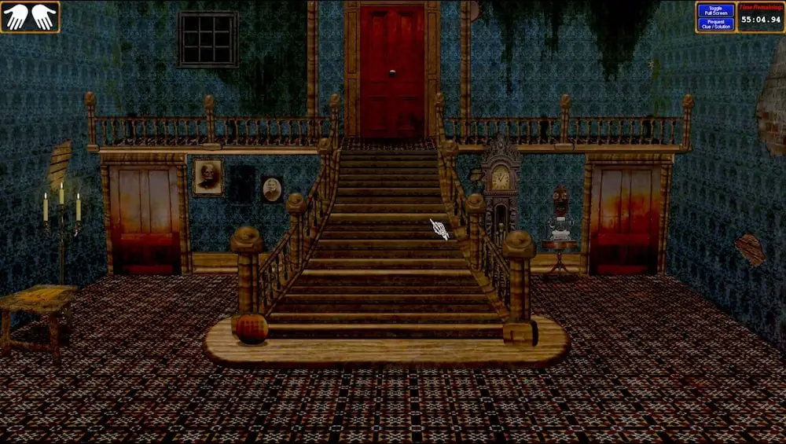

Using this title to look at point and click mechanics combined with older low poly models.

Cube Escape Collection by Rusty Lake

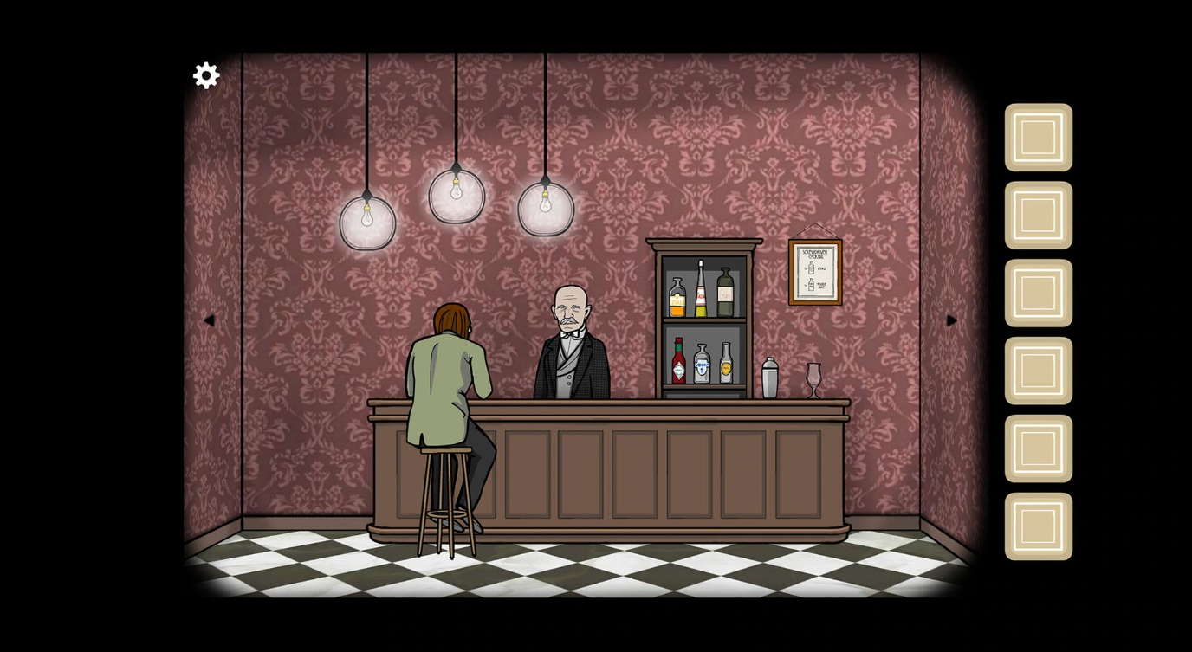

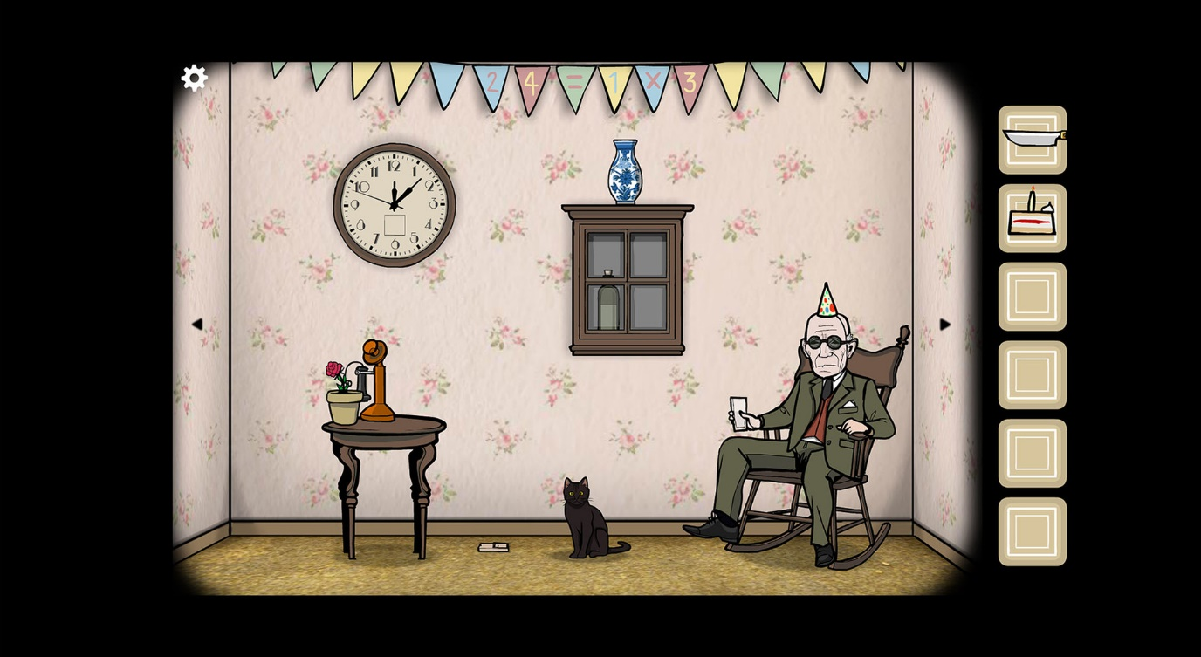

Using this game to look at eerie animations and themes and inventory systems.

Escape Impossible: Revenge by FunGamesMobile

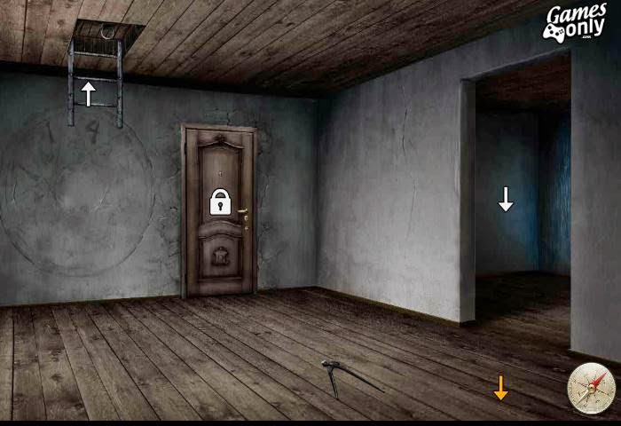

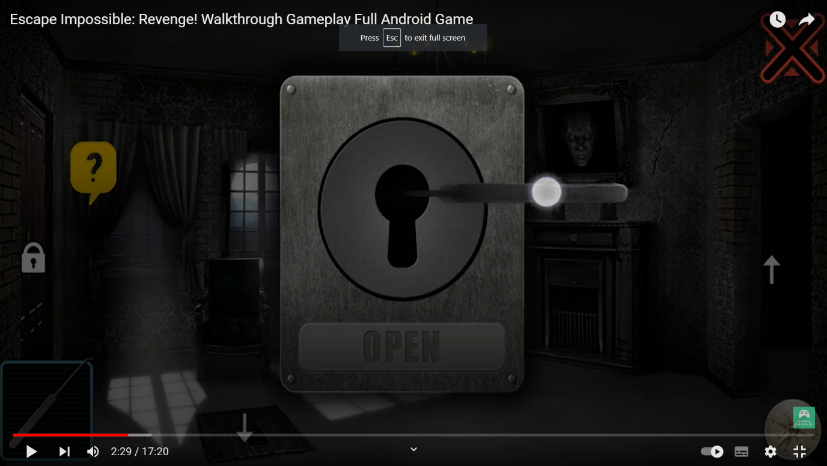

Using this game to look at puzzles that overlay the game scene, instead of zooming in on the puzzle in the scene like in the Cube Escape collection.

PuppetCombo Games

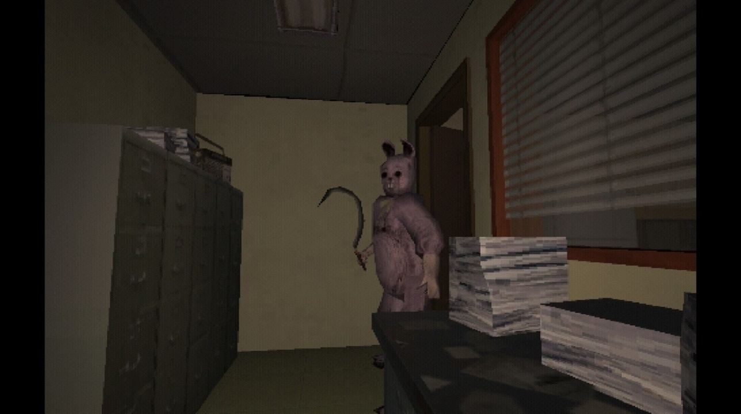

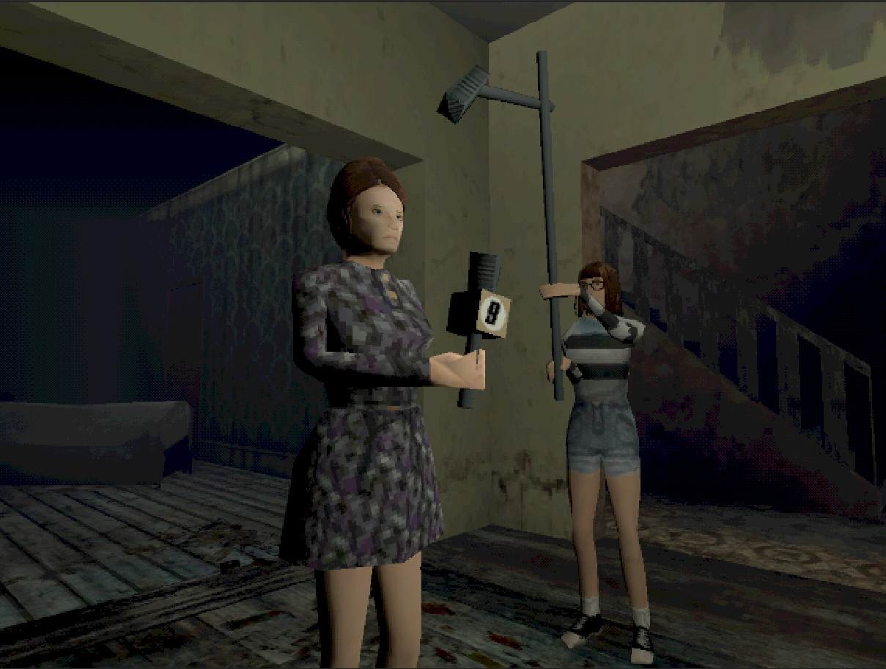

Using this game to look at modern games in Ps1 style graphics with low res textures, VCR effects, and sound. An 80’s game horror aesthetic, a personal favorite of mine.

After deciding upon certain gameplay mechanics as a group I began creating a level layout and furniture assets to go into the scene.

Below is a rough layout of the level. Elements such as cabinets, fridge doors, blankets, and curtains would need to be opened and closed when the player clicks on them.

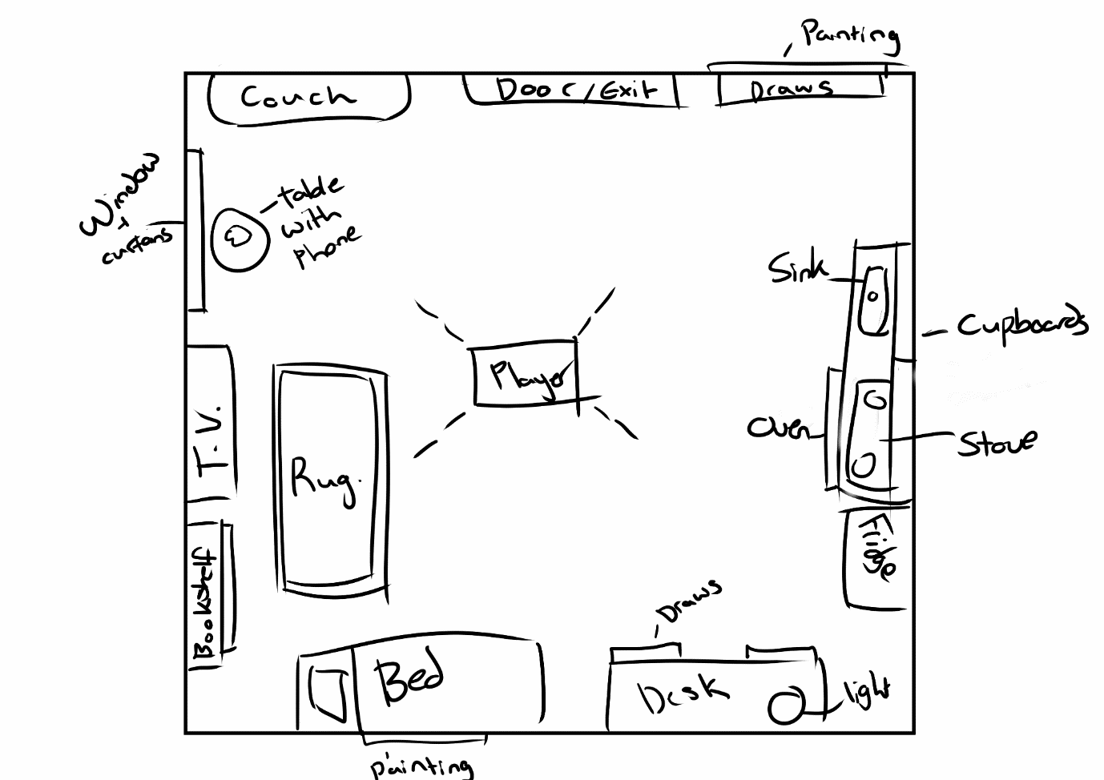

I later decided to exclude draws as the static camera that can only look at one wall at a time would hinder the visibility of items in the draws when opened.

I sourced a Unity shader that would allow me to create textures and materials in the PS1 style. The shader I decided to use was the URP-PSX shader by Kodrin on Github.

<https://github.com/Kodrin/URP-PSX>

After adding the shader and learning how to implement and edit it I began working on the furniture assets needed in the room. I created the assets and edited their Albedo and UV maps in Blender before exporting them into unity and applying the URP-PSX shader.

The list of *furniture assets* and their animations include:

* Couch
* Bookshelf
* Desk
* Chair
* Kitchen Cabinets X4 - can open and close
* Sink and cabinets X2 - can open and close
* Oven
* Fridge
* Rug
* Bed and blanket
* Window and curtains - can open and close
* T.V. Set
* Brick phone
* Side table
* Painting X2
* Door - can open

Next, I was given a list of *puzzle items* that were needed in the room:

* A box wrapped in plastic - plastic can be removed and the box opened
* A box that needs a code - can be unlocked and opened
* Knife
* Fork
* Door Key
* Book - can be opened
* Bed sheet- can be pulled back

* I sourced external image textures to apply to the URP-PSX, all source references are listed at the end of this document.

Using a combination of DoTween and normal animations I created a Script that allowed for the opening/closing and required movement of the above assets. Puzzle items and the Door can be ‘locked’ through a boolean, allowing players only to open them (play the opening animation) when they use a specific item, such as a Key needed for the door.

I then created *Creepy Animations*. These were animated events that contributed to the horror and eerie aesthetics of the game and can be played when needed.

Creepy Animations include:

* The brick phone vibrating and ringing, then audio of a woman and her child followed by the phone hanging up
* An audio of water running and blood appearing in the sink
* A figure appears in the window and quickly moves away
* A painting suddenly falling
* The final animation is the *End Distortion* animation which is triggered when the player unlocks and opens the main door. Static audio begins to play and the scene becomes pixelated. The figure from the window stands in the doorway and comes towards the player. The pixelation increases until the player can’t see anything.

The pixelation effect was done by recording changes on the URP-PSX shaders Pixelation Controller script’s pixelation height and width fields.

*All audio was sourced from Freesound.org and referenced at the end of this document.

These animations are controlled by the Creepy Event Controller which has an optimized script that allows for the above animations to be called when required in other scripts. Some animations require additional checks to be made in other scripts for them to be effective. Such checks include not looking at the sink when the running water audio plays and the blood appears, and having the curtains open when the figure appears by the window.

Project screenshots

Each object's URP-PXS shader was edited to allow for the correct texture resolutions and vertex jittering effect during camera and object movement.

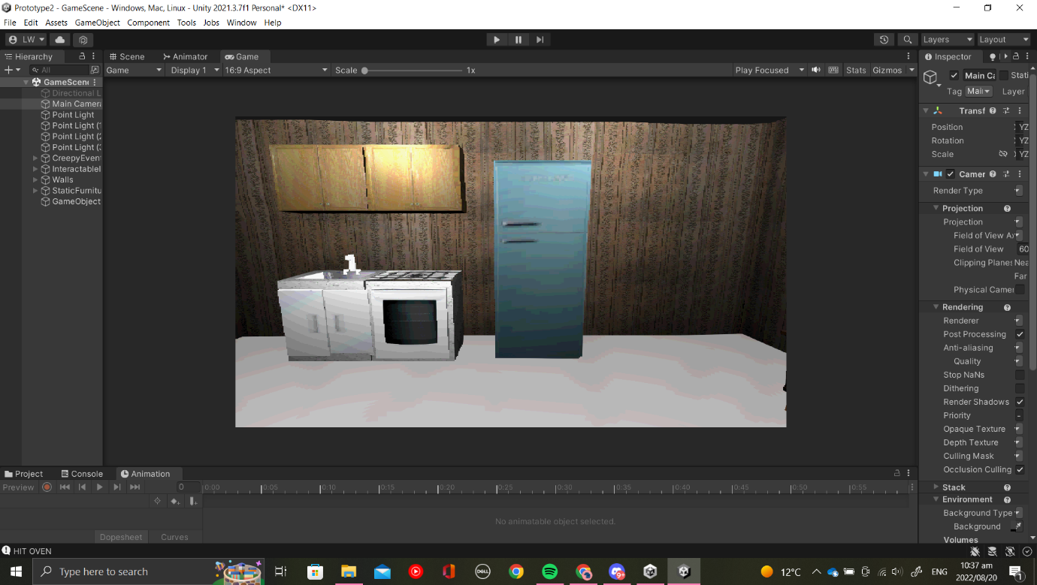Kitchen set closed

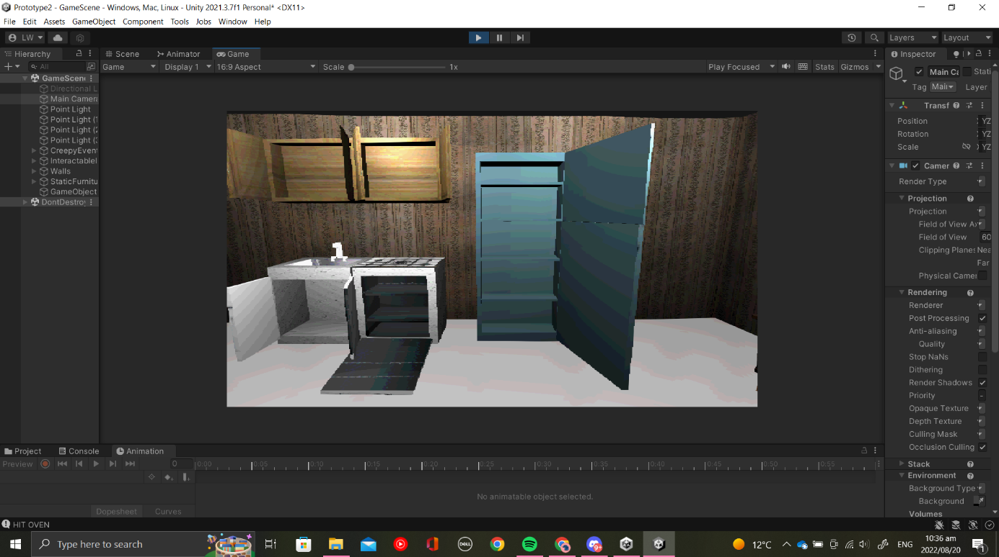Kitchen Set opened

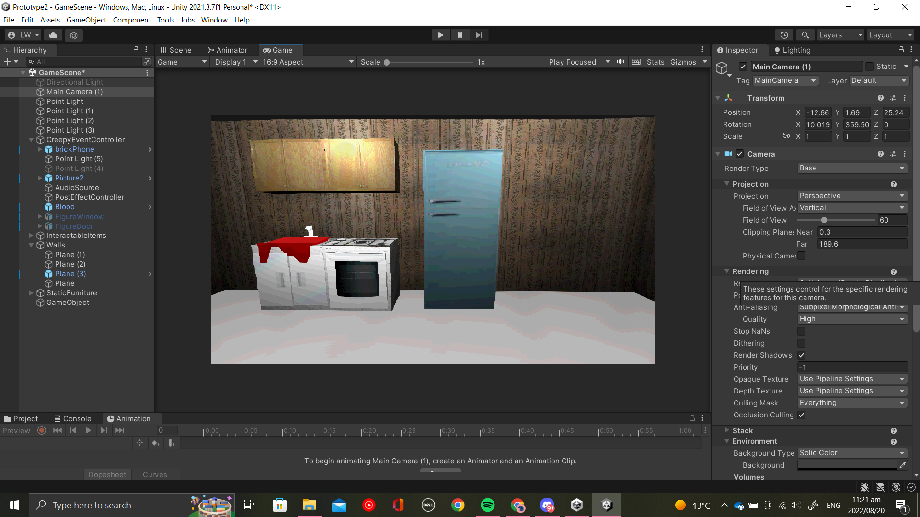Blood in sink

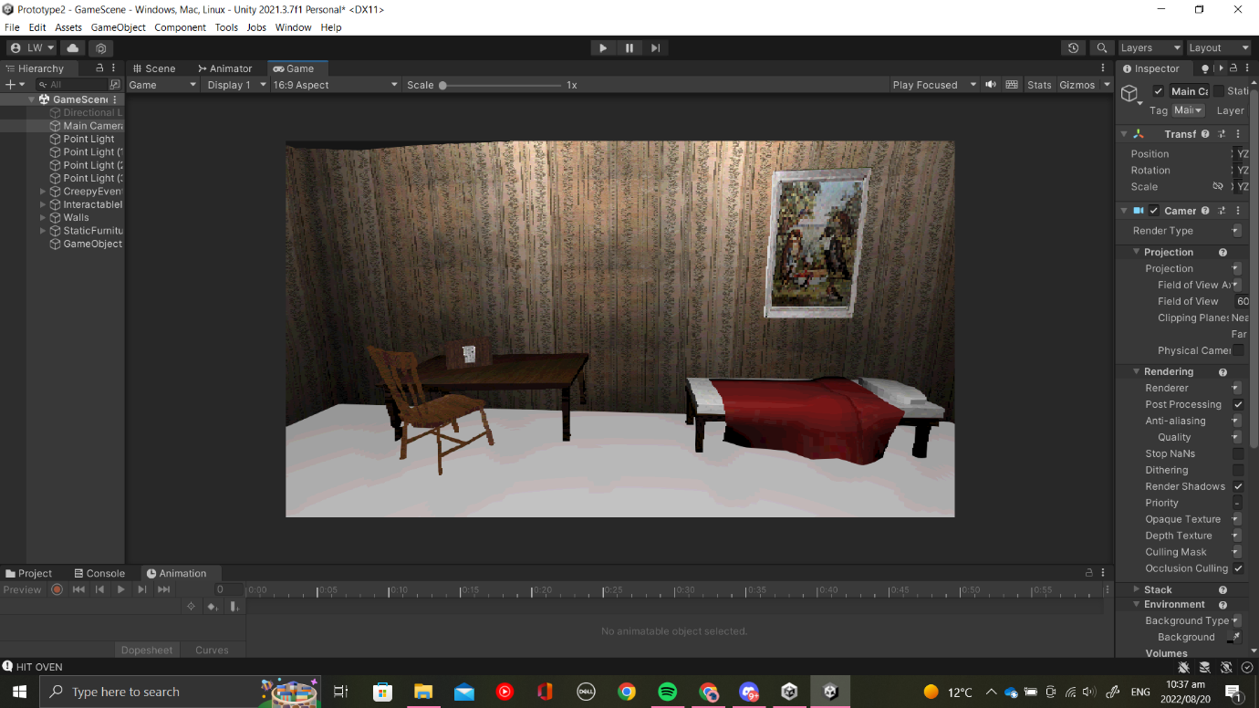Box with code on the table

A book that can open on shelf and phone on the table

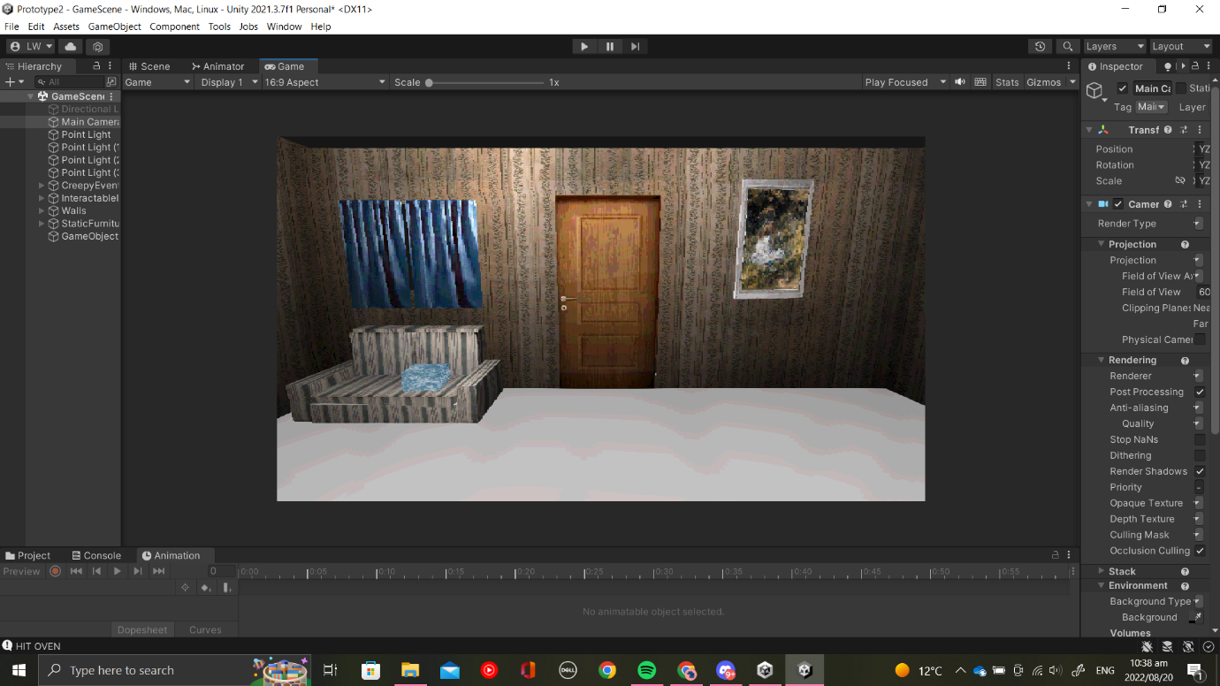

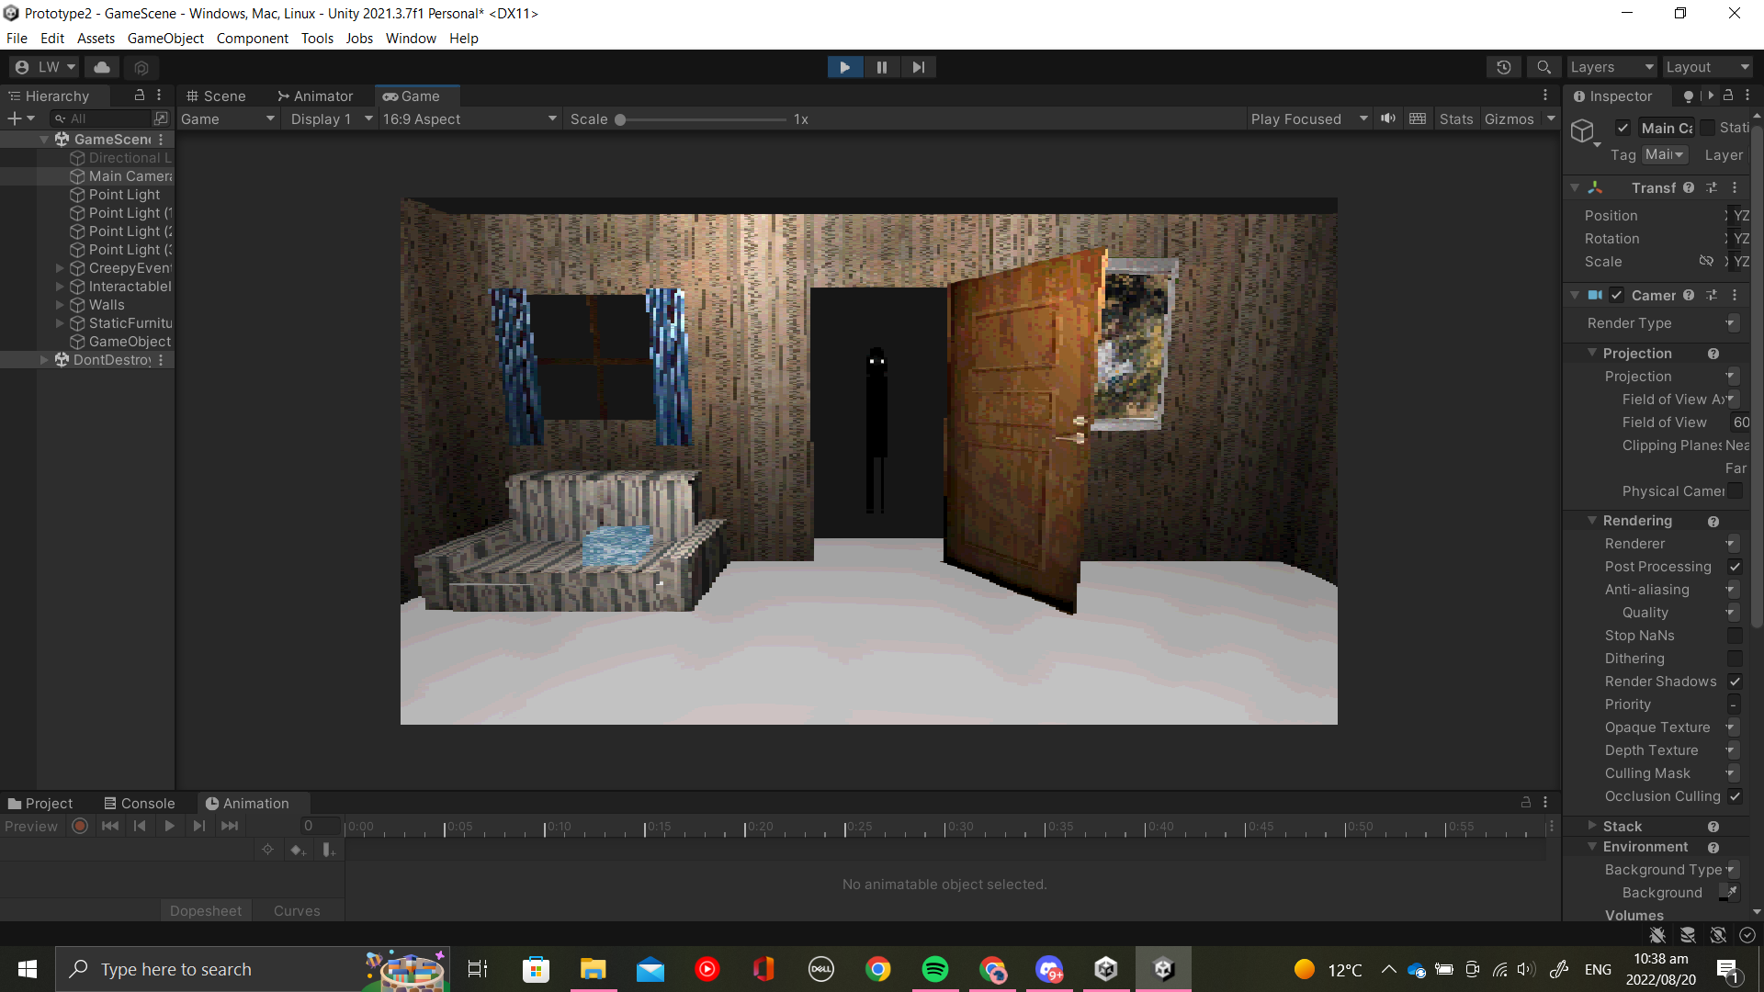Curtains opened figure in the doorway

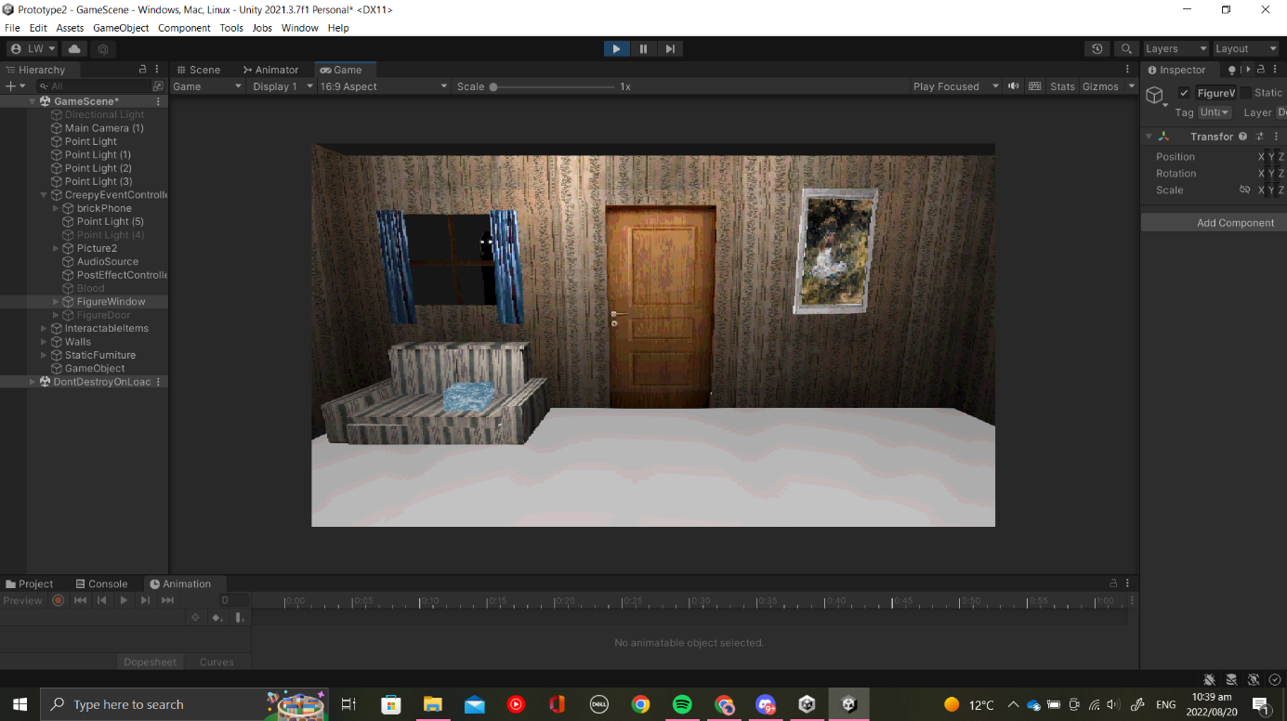Figure at window

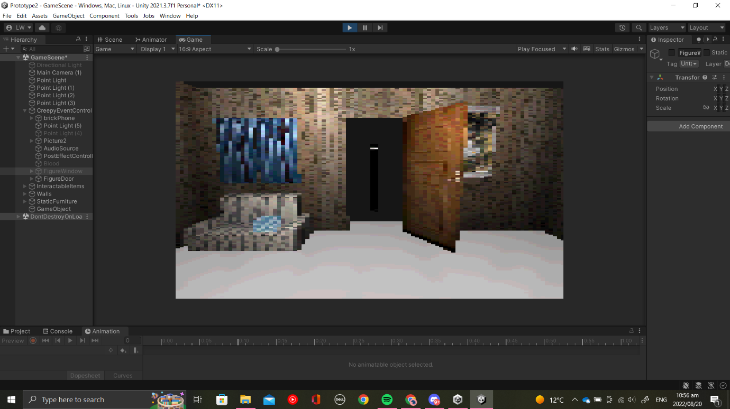Pixelation effect of end Distortion Animation

Reflection

Creating both the assets and animations for this prototype was a long and difficult process. I feel that I underestimated how much time would be required to learn how to use the URP-PSX shader and edit it until I got the effect I wanted. I had problems when using DOTween as the axis never correlated with the ones I wanted to move, hence I opted to use normal animations for items that didn't open on a vertical hinge, such as the oven, phone vibration, and bed sheet, as struggling with DOTween was taking too much of my time. I would like to go back to it however and figure out why I was having so much difficulty with it as I have used it in projects before without any problems.

I enjoyed the challenge of keeping assets extremely low poly as I often wanted to add more detail to the mesh itself, however, being restricted to more simple shapes and image textures for detail showed me ways to create good assets without having to sacrifice the game’s performance. I am very pleased with the game's aesthetic result and I am glad that I took this opportunity to try recreate a style that I’ve always wanted on modern hardware.

References

Texture References:

"Floor Mat PNG Free Image" at https://www.pngall.com/floor-mat-png/download/57922 under Creative Commons

"1980's Brick Phone Image" by Brad Helmink

"Kitchen Cabinets image" from Second Life Marketplace at <https://marketplace.secondlife.com/p/Kitchen-Cabinets/3965512>

"Wood Door" by safakoguz on 123RF at <https://www.123rf.com/photo_10697487_wood-door.html?vti=ocmx8vb8laqiuwiy59-1-52>

"Curtain" by Noize Watch at <https://www.kindpng.com/imgv/hhmiTbx_curtain-hd-png-download/>

"24-inch freestanding gas" at <https://www.jcperreault.com/en/products/ge-cuisiniere-amovible-a-gaz-de-24-po-jcgas300dmww>

"Dark brown wood texture background with design space" by Jubjang at <https://www.rawpixel.com/image/4062441/photo-image-background-texture-wall>

"Bathroom Cartoon Transparent PNG" by Yndyhktwlg at <https://www.subpng.com/png-6ef077/>

"Grey And White Stripe Material 2-Seater Couch" image at <https://lifestyleatbalitrading.co.za/grey-and-white-stripe-material-2-seater-couch/>

"Bellini BG905X review" image at <https://www.choice.com.au/products/home-and-living/kitchen/cooktops/bellini-bg905x>

"Old TV" by RF Boogich on Getty Images

"Vintage decorative wallpaper surface with a floral pattern from the ancient texture of an old house interior - victorian background wallpaper" by donmer101 at <https://www.123rf.com/photo_149811810_vintage-decorative-wall-paper-surface-with-a-floral-pattern-from-ancient-texture-of-an-old-house-int.html>

"Wooden twin size single bed with red linen isolated on white background." Include clipping path. 3d render by Dima Moroz at <https://www.shutterstock.com/image-illustration/wooden-twin-size-single-bed-red-602871668>

"Quartz surface white for bathroom or kitchen countertop" By stevanzz at <https://stock.adobe.com/search?k=granite+countertop+texture&asset_id=329529115>

"Illustration of a metal ATM keyboard with numbers and buttons. For safe cash withdrawal - vector stock illustration" by FORGEM at <https://www.istockphoto.com/vector/illustration-of-a-metal-atm-keyboard-with-numbers-and-buttons-for-safe-cash-gm1320444868-407005383?phrase=number%20keypad>

TexturesCom_BookCovers0077_2_masked_S at textures.com

TexturesCom_Various0506_1_S at textures.com

TexturesCom_Plastic0144_1_S at textures.com

"Great Silver Brushed Metal Texture Background" at <https://www.freecreatives.com/textures/silver-texture.html>

"Dark Wood texture" by mutaaex at <https://www.deviantart.com/mutaaex/art/Dark-Wood-texture-280856160>

"Galanz - Retro 10 Cu. Ft Top Freezer Refrigerator - Blue" image at <https://www.bestbuy.com/site/galanz-retro-10-cu-ft-top-freezer-refrigerator-blue/6437997.p?skuId=6437997&intl=nosplash>

"Who killed cock robin?" by McGill Library at <https://unsplash.com/@mcgilllibrary>

"A Girl with Flowers on the Grass" by Maris at <https://unsplash.com/photos/VsnDYMWollM>

Audio References:

"Phone hang up/ suspend" by kyliank at <https://freesound.org/people/kyliank/sounds/178537/>

"HiDaddy.wav" by daveincamas at <https://freesound.org/people/daveincamas/sounds/31490/>

"synthesized telephone rings.flac" by Timbre at <https://freesound.org/people/Timbre/sounds/349187/>

"Accidental Noise, Zoom H6.wav" by InspectorJ (www.jshaw.co.uk) of Freesound.org

“Human body fall” by OptronTeam at <https://freesound.org/people/OptronTeam/sounds/553741/>

"OPENING THE TAP.wav" by taisssss at <https://freesound.org/people/taisssss/sounds/515584/>

## Process (Ash)

Hypothesis

How to create an escape room puzzle game

How to create a creepy atmosphere in the game

How to incorporate an old/retro type art style into the game

Process

I started by adding the camera controls to allow the player to view each wall. I attempted multiple approaches to allow the camera to move smoothly between walls, but ultimately all the methods I attempted were glitchy and did not create the desired effect. The final game simply jumps between each wall.

When viewing each wall, there is a chance that certain creepy events may be triggered on a different wall. Each time the player view changes, a random chance is calculated for events on every wall except the one being viewed. Those events are then called in an attempt to draw the player back to that wall. There is also a creepy event that may be triggered when the player opens the curtains, which is also randomized.

Reflection

I ended up spending too much time trying to get the camera to move smoothly between walls, but was unsuccessful. That time would have been better spent working on the inventory system, which I was unable to complete. The incorporation of creepy events being triggered randomly was successful, since they happen when the player is not facing them which is the desired outcome.

I learnt a lot more about quaternions and rotation while coding the camera movement, which I feel was a valuable experience. Calling functions from different scripts is not something I do often, which was also good practice. I enjoy horror games, so it was fun being part of creating a creepy-feeling game.